1.

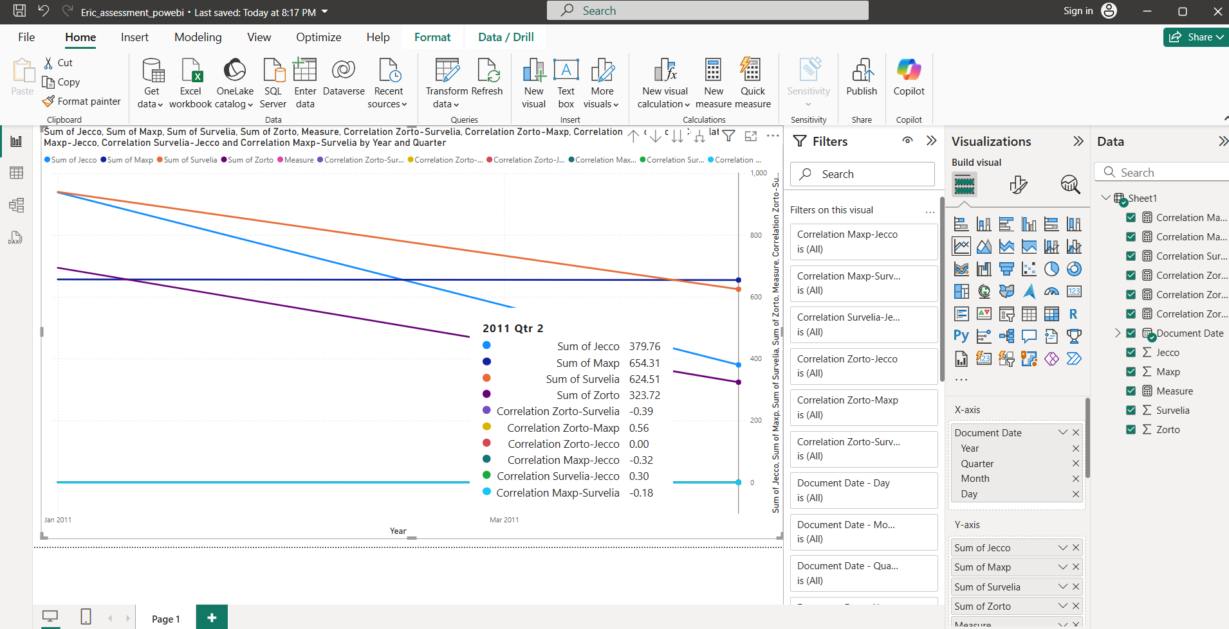

2.



**Analysis:**From the line chart, we observe that the stock prices of Zorto and Maxp tend to move closely together over time, indicating a positive correlation. Survelia shows some similar trends but with noticeable deviations at certain points, suggesting a moderate correlation. Jecco, on the other hand, often moves differently compared to the other three stocks, pointing to a low or negative correlation.  
The correlation matrix confirms these observations, highlighting a strong positive correlation between Zorto and Maxp, a moderate correlation with Survelia, and a weak or negative correlation with Jecco.